**DEPARTMENT OF COMPUTER SCIENCE – UBIT**

**ASSIGNMENT-02**

**“Assembly language”**

**CSSE – 403**

**Muhammad Suleman**

**Section ‘A’ Evening**

**EB23210106101**

**1. Display the contents of the defined memory locations 120, 133, 122 using D command.**

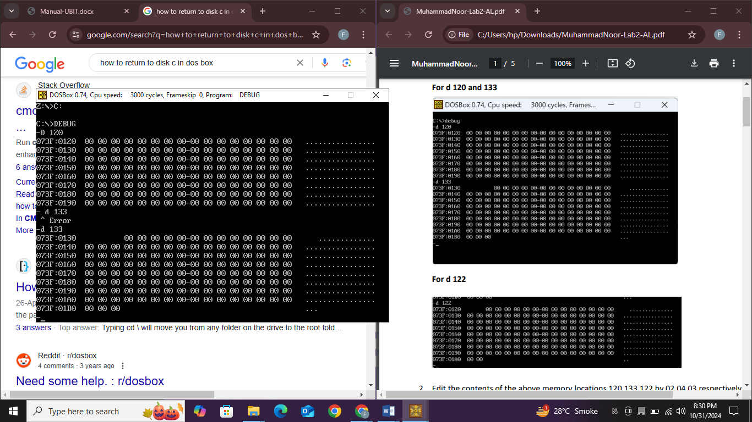

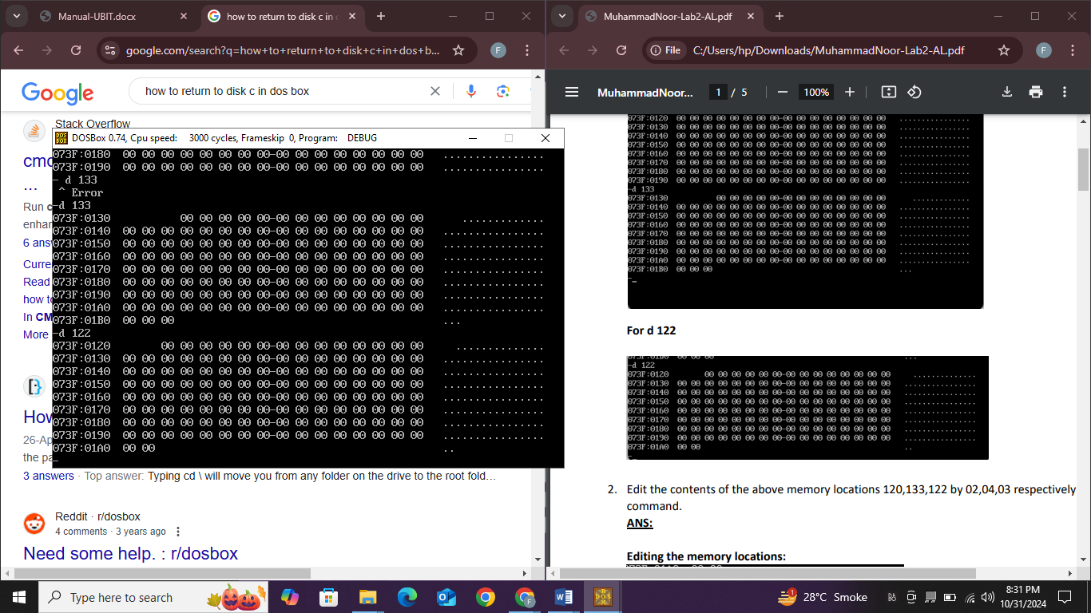

**2. Edit the contents of the above memory locations 120,133,122 by 02,04,03 respectively using E command.**

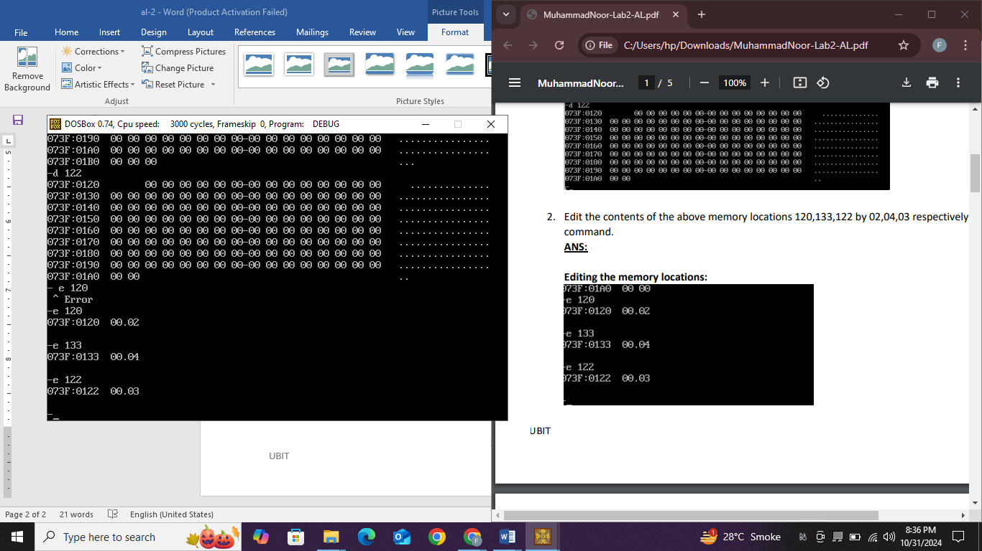Editing:

**3. Then again display the contents of the memory locations which we edit in the Task# 2.**

Edited memory locations:

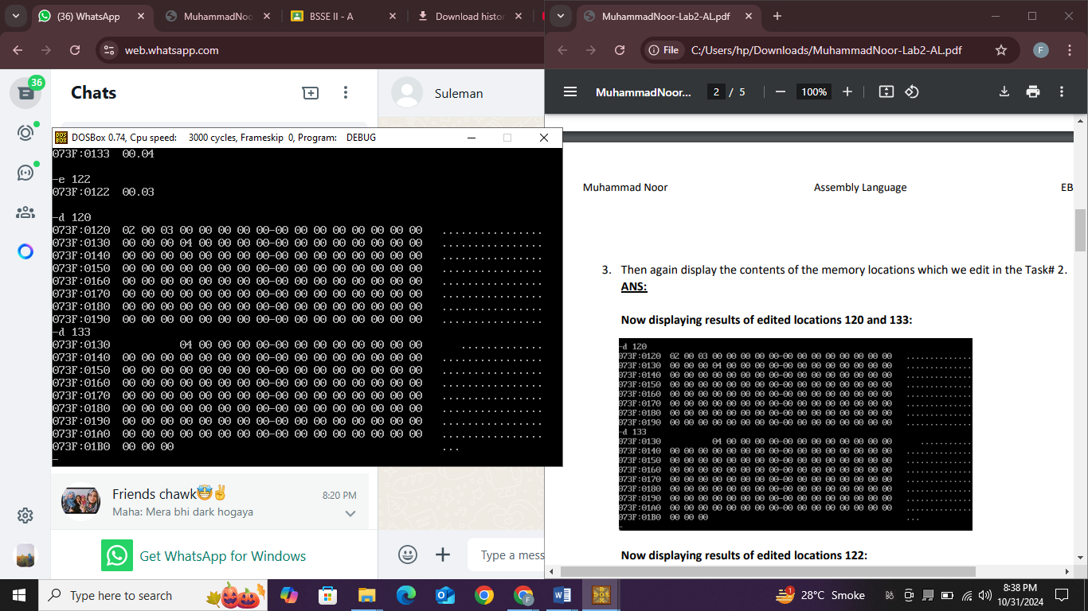

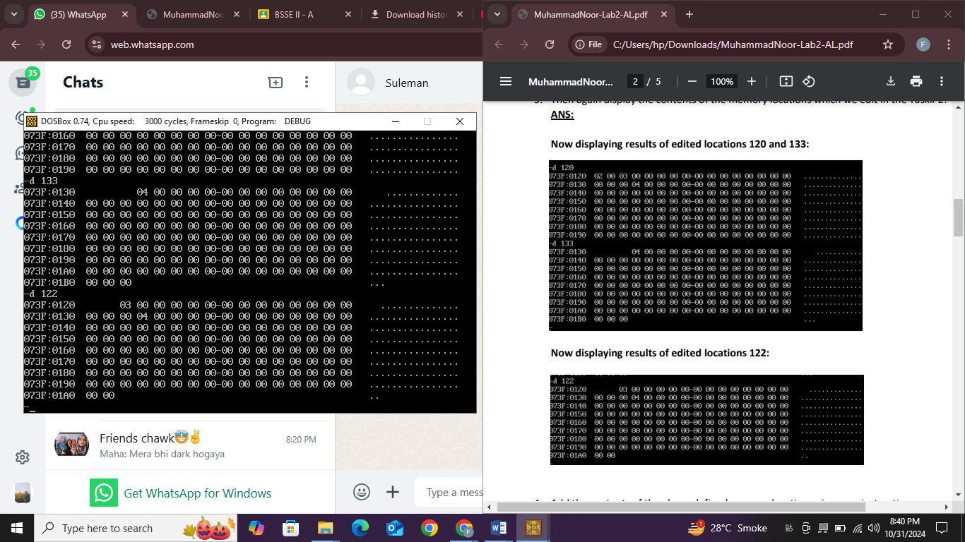

**4. Add the contents of the above defined memory location using mov instruction**

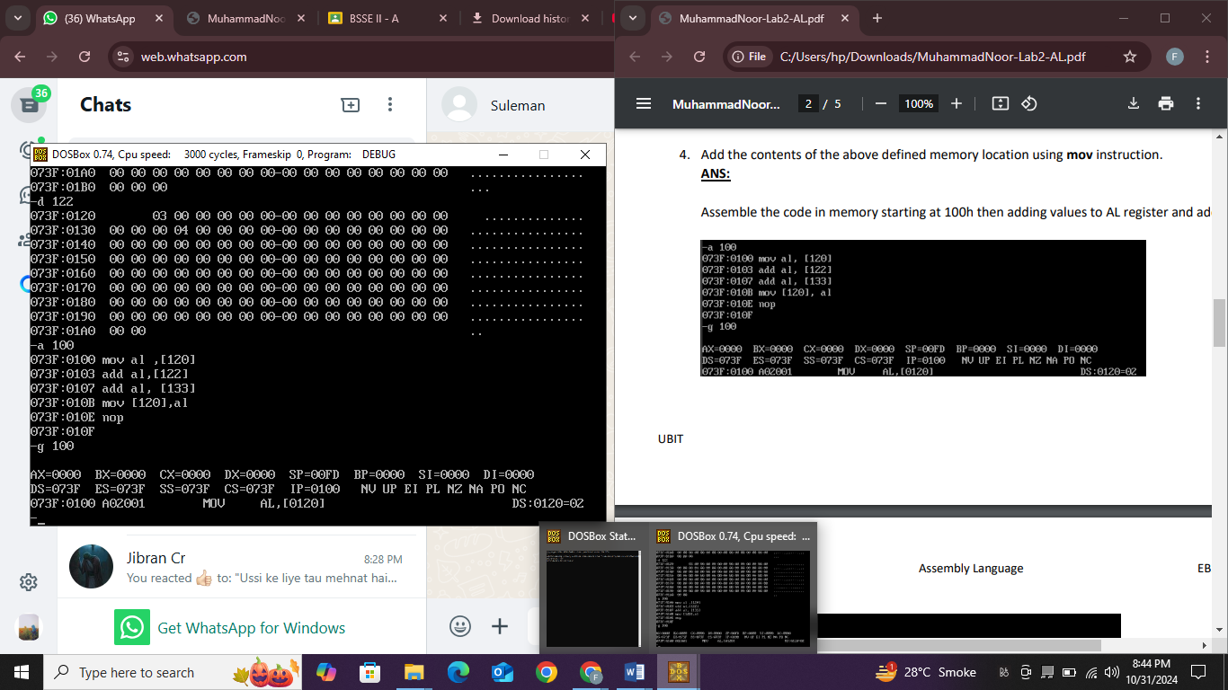

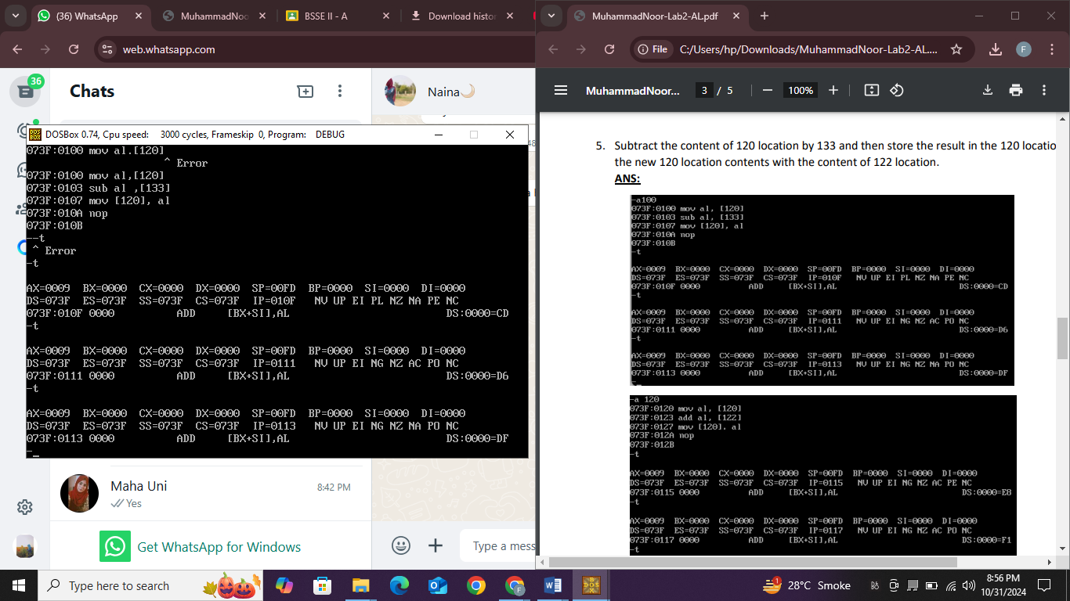

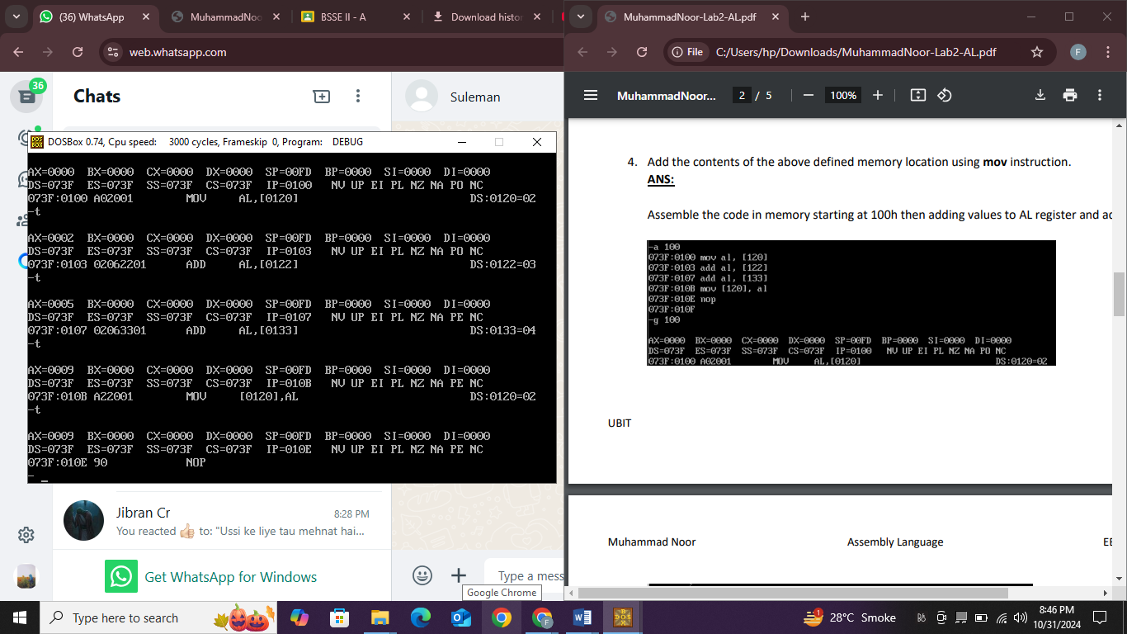

**5. Subtract the content of 120 location by 133 and then store the result in the 120 location and add the new 120 location contents with the content of 122 location.**

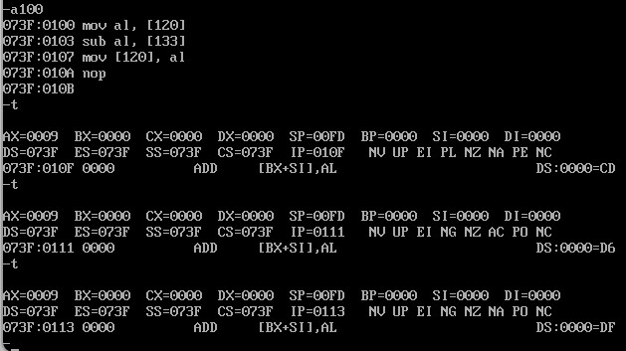

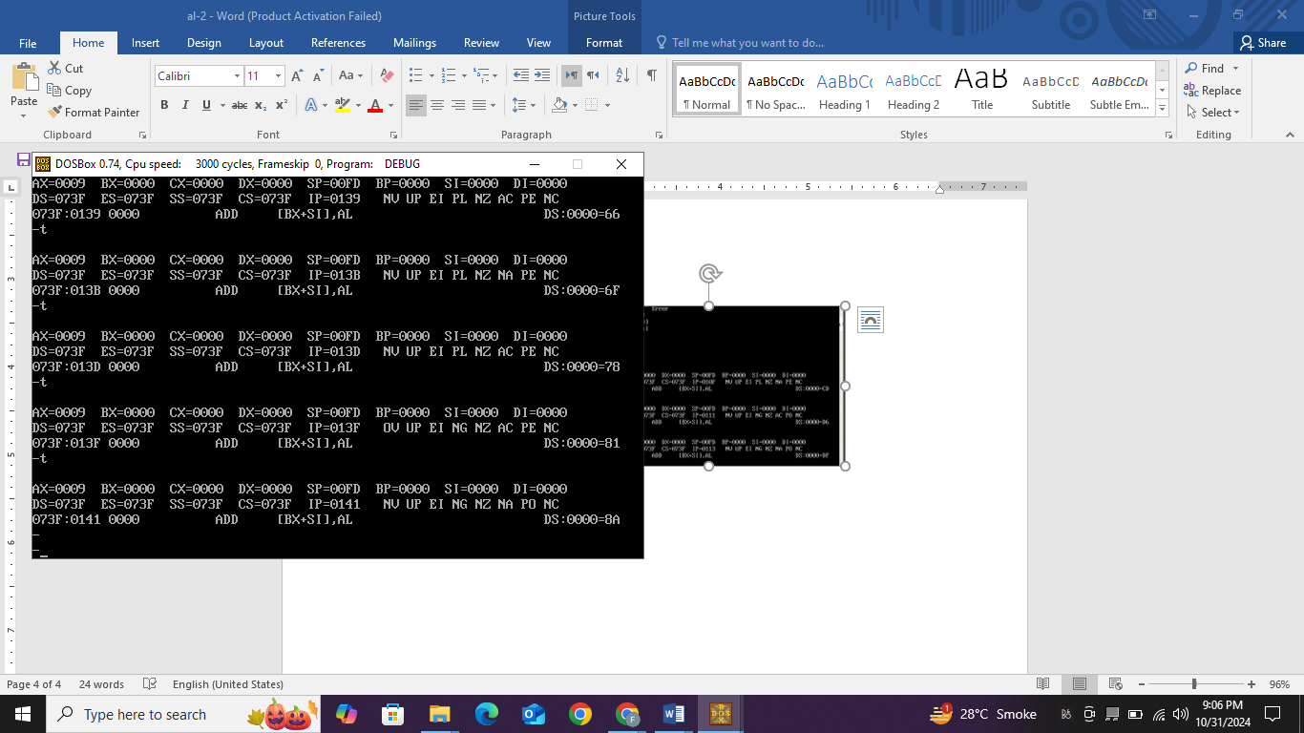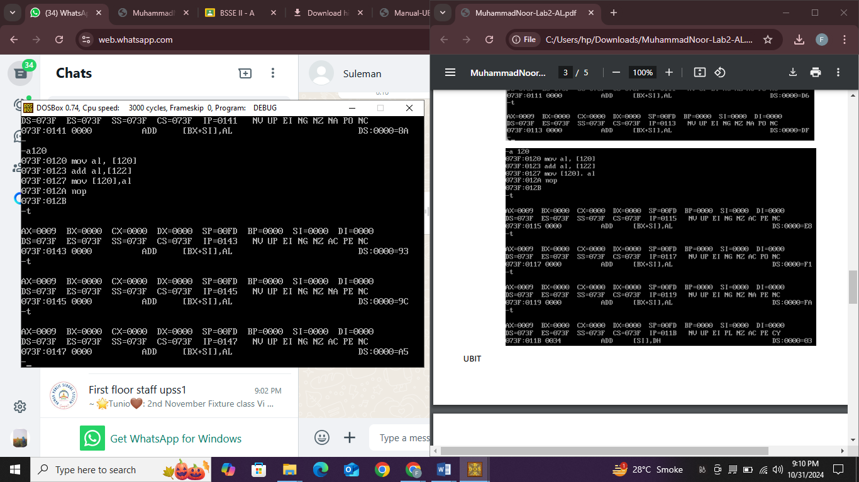

* **ACTS**

**Act 1.1)** Use debug command U100 to un-assemble the instructions in ACT 1.1. What is the machine code corresponding to each assembly code instruction.

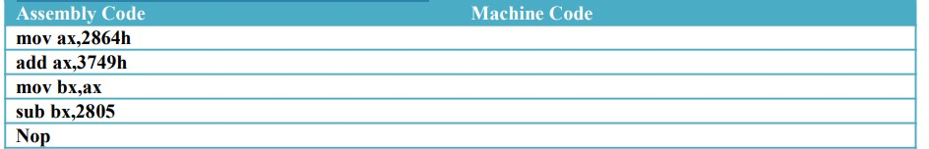

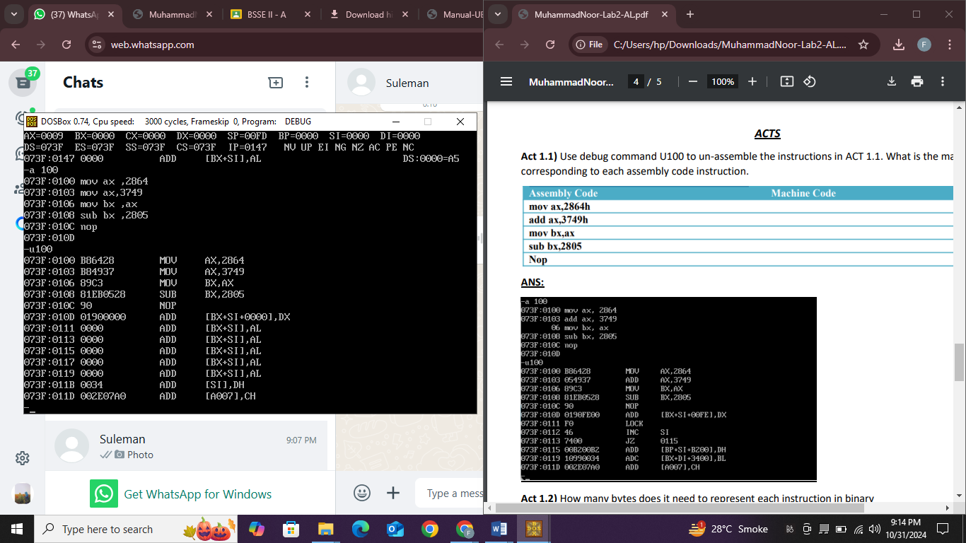

**Act 1.2)** How many bytes does it need to represent each instruction in binary

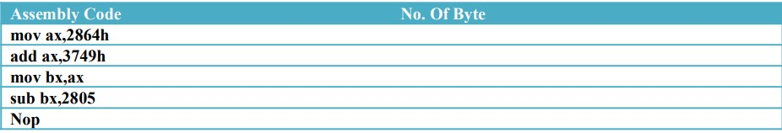

Ans:

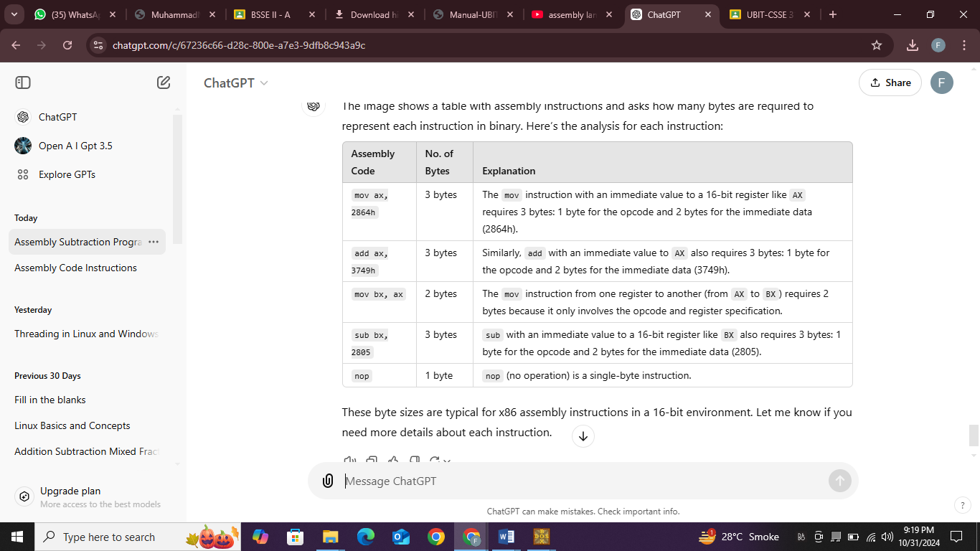

**Act 1.3)** What are the contents of CS , IP , AX & BX ?. Use debug command R to display these information.

**ANS:**

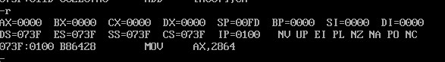

CS(code segment): 073F, IP(instruction pointer): 0100, AX: 0000, BX: 0000

**Act 1.4)** Predict the contents of the following registers after execution of each instruction CS, IP, AX, BX:

